
Project Name: Property Management System
Client Name: Noida Authority
Industrial Department

North Shore Technologies Pvt. Ltd.
_________________________________________________________________
Logix Techno Park ♦ Sector 127 ♦ Noida – 201301 ♦ India
Phone : (120) – 404 3401

Contents

Introduction 5
Purpose & Objectives 5
User Classes and Characteristics 6
Industrial – Complete Process 7
1. Allotment Process 8
1.1 Scheme Creation 9
1.2 Adding property(s) to the scheme 9
1.3 Scheme Notification to Public 9
1.4 Customers submits application 9
1.5 Adding Customer details 9
1.6 Approval for Successful Applicants 9
1.7 Allotment Letter Issuance 9
1.8 Business Rules for Allotment 10
2. Request for Lease Deed Execution 11
2.1 Payment of Allotment Money 12
2.2 Failure to pay allotment money 12
2.3 Issuance of Checklist 12
2.4 Time period for lease deed 12
2.5 Lease Deed Executed 12
2.6 Initiation of Lease Rent 12
2.7 Business Rules for Lease Deed 12
3. Request for Possession Certificate 13
3.1 Consumer submits application 14
3.2 Approval from engineering department 14
3.3 Re-Adjustment of Change in Area 14
3.4 Business Rules for Possession 14
4. Request of Completion Certificate 15
4.1 Consumer submit Completion Certificate Request 15
4.2 Validation from Planning & Account Department 16
4.3 Business Rules for Completion Certificate 16
5 Request for Functional Letter 17
5.1 Consumer Submits Functional Request 17
5.2 Validation from Account Department 18
5.3 Approval from Manager 18
5.4 Functional Letter Issuance 18
5.5 Business Rule for Functional 18
6 Request for Transfer of Property 20
6.1 Consumer submits Application 20
6.2 Validation from Accounts & Legal Department 20
6.3 Consumer pays transfer charges 20
6.4 Approval from Manager 21
6.5 Transfer Deed Executed 21
6.6 Business Rule for Transfer of Property 21
7 Request for Issue of Mutation (Substitution) 23
7.1 Consumer submits Application 23
7.2 Validation of Documents 23
7.3 Approval from manager 23
7.4 Business Rules for Mutation 24
8 Request for Mortgage 25
8.1 Consumer submits mortgage request 25
8.2 Validation from Account department 25
8.3 Approval from Manager 26
8.4 Mortgage Letter Issuance 26
8.5 Business Rules for Mortgage 26
9 Request for Change in Constitution (CIC/CIS/CIN/COD) 26
9.1 Consumer submits Application 27
9.2 Validation from Account department 27
9.3 Approval from manager 28
9.4 CIC Letter Issuance 28
9.5 Business Rules 28
10 Request for Rent Permission 33
10.1 Consumer submits application 33
10.2 Validation from Account department 33
10.3 Approval from manager 34
10.4 Business Rules for Renting 34
11. Miscellaneous Business Rules 36
11.1 Surrender 36
11.2 Restoration of Industrial Plot 36
11.3 Conversion 36
12. Payment Schedule Logic for Industrial Department 37
12.1 Payment Schedule Formulae 37
12.2 Dues Calculation 39
12.3 Miscellaneous 41

Introduction

New Okhla Industrial Development Authority plays a significant role in building world class infrastructure which is situated in the vicinity of Delhi NCR. The development of infrastructure includes the Institutional development, Commercial development, Industrial development, Residential/Housing development, Group housing development, roads and transport infrastructure development and horticulture development. Considering the potential growth rate of NOIDA, optimized business processes are needed to serve the Customers with different establishments like industrial, commercial, residential, institutional and housing.
Currently, the property management system in NOIDA is being managed on the power builder. The business processes for different kinds of service delivery are effective but lacking in efficiency. In the current working system, the technical framework is old and almost obsolete. The data management system is in physical form and important wings of the authority, such as planning and engineering, have no effective system to manage their activities. There is a complete lack of interface at authority level for internal communication with departments. The existing web builder system shall also run for certain time as determined by the Authority during the transition period. Effective business processes are required across the different entities\departments of Noida to attain the desired level of efficiency and ensure better services to the Customers\end customers. The need is to bring an integrated database which will allow the work processes to be performed efficiently and to introduce a tool or dashboard for higher management/officers to monitor the related activities.

Purpose & Objectives

The overall purpose of this project is to build up an integrated Property Management system. This system would primarily facilitate access on web browser, e-enabling various processes across and allow adoption of a comprehensive approach towards gaining the efficiency. The system would enable the working staffs, officer etc. to access integrated data from different business processes, thus, enabling them to promote information sharing for critical operational as well as strategic decision-making. It would share the relevant information across the different departments which will help in making operational as well as strategical decision.
The scope of this project is to develop the Property Management Information System which will help the Noida officials and Customers to manage/view the related information. This system would:
- Show categorisation of different property types.
- Reflect the various property details (Built up area, Plots etc.), lease deed execution, mortgaged properties, transferred properties, completion certificate of the properties and account related details and payment history.
- Show the property owner name, property status (possession handed over, rented, allotted, functional etc.), area and location of property.
- Show the detailed payment history, paid/due payments, future payment due dates and amount.
- Send email notifications & reminders to customers about the due payments, if not paid timely. The information system will also send SMS alerts twice in a month (One month and 15 days before any payment due respectively).
- Show JAL payment receipts and dues, complaints & enquiry status from the Customer charter and any legal cases associated with the property.
- Contain a payment gateway for the customer for online payment of various instalments & fees related to property.
- Contain a dashboard used to generate reports on various parameters. This will ensures compliance and enhances the decision making between the Noida Authority Officials. Customers will also be able to generate reports regarding their payments (paid/dues).
- Enable the Noida Authority Officials to search and update any property using filters (property id#, owner name, address etc.) as per the requirements.
- Enable the Customer to search for the details of their property, payment etc. The system will also allow the Customer to register their query/complaints to their related property and able to track their complaints and query.

User Classes and Characteristics

The functioning of the department is classified on the basis of the below specified roles under the housing department for better understandability:
- Manager Level
The manager is a key role whose prime responsibility is to validate the requests received from the assistant level. After the successful validation of the request, the manager level passes on the approval or the cancellation.
The manager will approve/reject the request received from assistant after getting the direction from the below departments:
  - Account Department
  - Legal Department
  - Engineering Department
  - Planning Department

- Assistant Level
The assistant is responsible for all the activities of housing department and also involved in processing all the property request received from the Customer. He is also responsible for maintaining the important letters associated to the allottee properties.

- Customer Level
The Customer is involved in each activity of the property process model and is responsible for submitting the requests along with required documents to the assistant for the initiation of the same.

Industrial – Complete Process
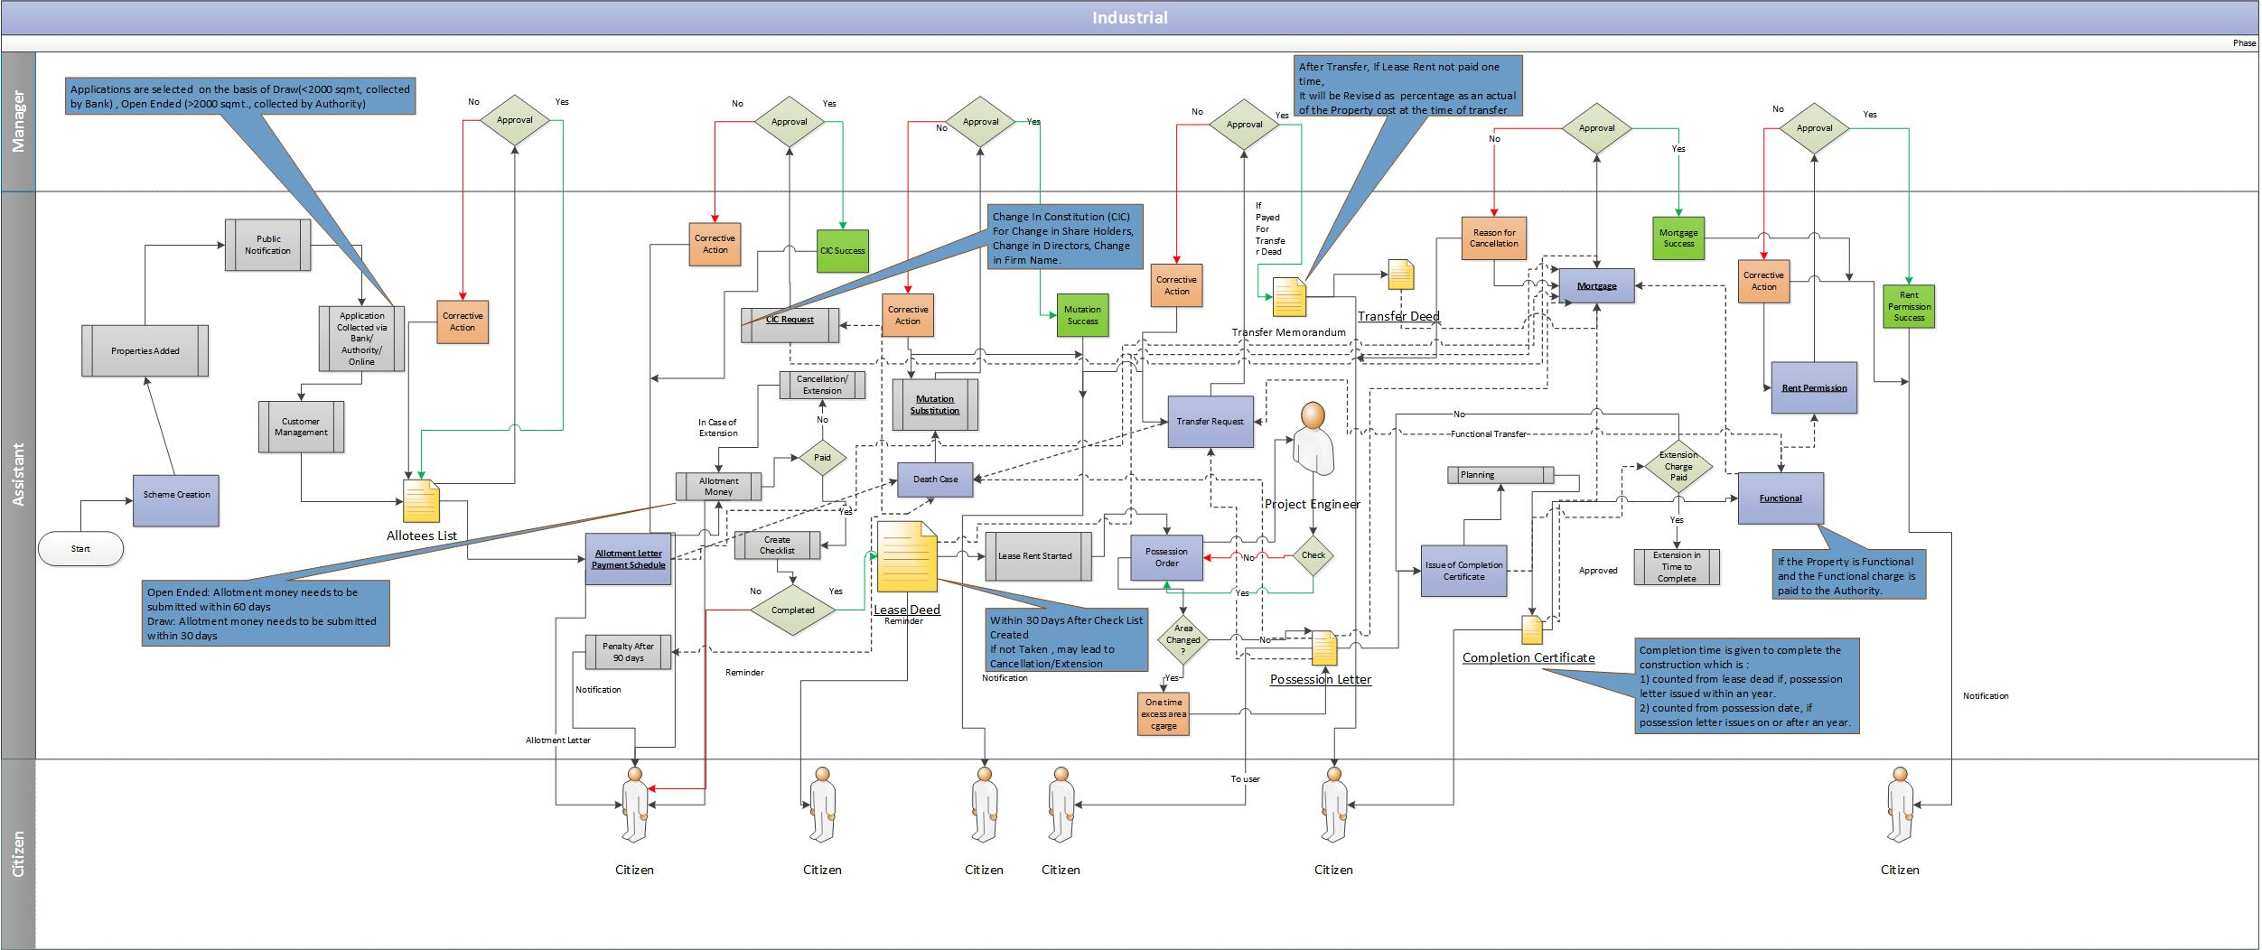

Allotment Process
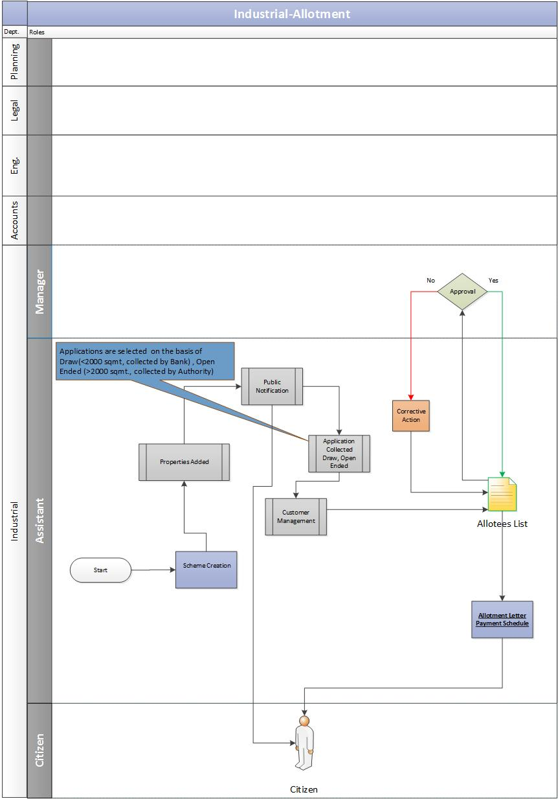

Scheme Creation
The foremost step is classification and the creation of the schemes looking at the demographic region for the Industrial sectors at Noida.
The assistant would enter the master data of the scheme into the system. Master data may vary as per the scheme.

Adding property(s) to the scheme
    - The assistant adds the property details under the newly created scheme. These property details are shared by the planning department. The planning department would also share the details of vacant properties from previous schemes.

Scheme Notification to Public
    - Post adding the properties to the respective scheme(s), the authority rolls out the scheme to the general public. This public notification contains the detailed information about the respective industrial scheme, the attached properties and the respective payment schedule and timelines.
    - The authority would notify the general public using various modes of communication such as advertisements in daily newspapers, web-portals etc.
    - The assistant would add the details for the respective scheme such as public notification details, modes of communication, signing authority etc. into the system.

Customers submits application
    - For Draw Based Schemes: The applicant can submit the application in two ways:
  - The applicant submits the application form along with the required document and fee to the registered bank.
  - The applicant submits the application directly onto the authority portal.

    - For Open ended schemes: The eligible applicants are invited for interview sessions that involves validation of all documents.

Adding Customer details
    - The assistant would add the details for all the applicants, received from the bank, into their respective system for draw based schemes. Similarly, the assistant adds details for all the applicants into the respective system for the open ended schemes.

Approval for Successful Applicants
    - Post customer management, the applicants are selected:
      - For Draw-Based schemes
        - The list of successful applicants is prepared and sent further to the manager for his approval.
      - For Open-Ended Schemes
        - The list of successful applicants, after the interview, is prepared and sent further to the manager for his approval.

Allotment Letter Issuance
    - Post approval of the allottee list from the manager, the allotment is done for all the successful applicants. The allotment letter along with payment schedule will be issued to the allotees.

Business Rules for Allotment

In case where the allotment is made for more than one plot to an applicant then for the purpose of location charges the same would be imposed on the entire area of all the plots. However, in such cases, if the allottee desires he can get the legal documents executed separately for each plot.

The rate of allotment for industrial facility plots would 1.5 times (may vary in future) of the rates plus location benefit charges as applicable.

The rate of allotment/location benefit charges are prevailing as on date, which are subject to change without any notice. The rates/locational benefit charges shall be applicable as prevailing on the date of issue of the allotment letter.

  - Allotment of industrial plots/sheds in shall be made on the basis of Sealed Tenders.
  - Allotment of plots, upto 2000 sq.mt, shall be made through the schemes advertised from time to time for limited period. The applicant is required to submit the application along with project report prescribed registration money and processing fee in the bank.
  - The allotment would be done through draw of lots which would be phase wise and area category wise. The applicants would also be obtaining specific location of their plot through this draw.
  - Unsuccessful applicants would be returned their registration money in due course. Under no circumstances, the application would be carried forward against future schemes/any other scheme.
  - Allotment of plots above 2000 sq.mtr shall be made through a close ended scheme and after evaluation of the project by the Screening Committee and approval of Chief Executive Officer.
  - Interested applicants shall be required to register their prescribed application from in the bank alongwith prescribed registration money processing fee project report documents in support of financial resources for financing the project etc.
  - Brochure of the scheme contained terms and conditions for allotment and application from shall be made available on prescribed payment through the bank advertised in the scheme.

Request for Lease Deed Execution
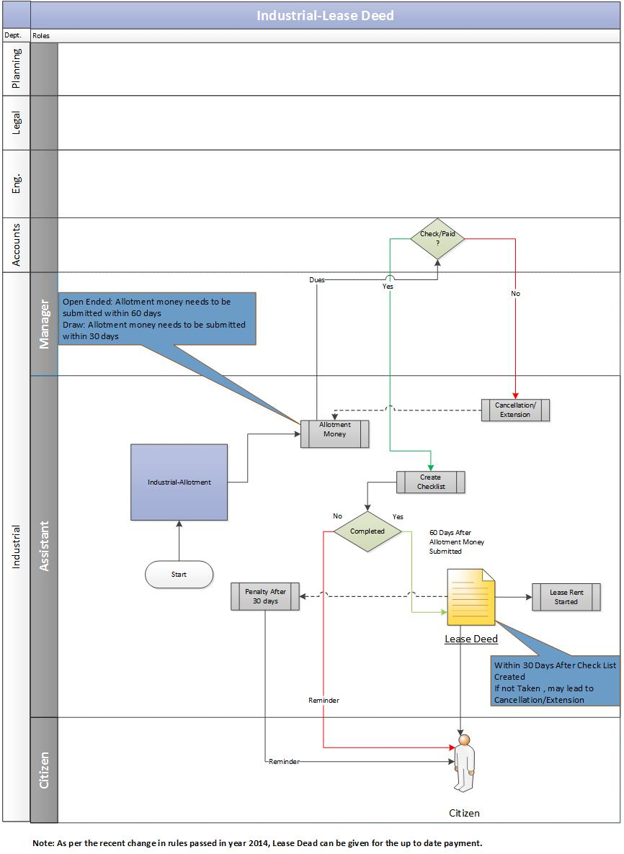

Payment of Allotment Money

    - Post the allotment process, the allotment money needs to be paid by the Customer to the authority within span of 30 days (for Draw-based schemes) or 60 days (Open-Ended schemes). Allotment money is calculated as 30% of the total cost.

Failure to pay allotment money
    - If the allotment money is not submitted within 30 days (for Draw-based schemes) or 60 days (Open-Ended schemes) to authority then it may lead to below scenarios:
      - Case of Extension: If the Customer is unable to submit the allotment money within time period of 30 days (for Draw-based schemes) or 60 days (Open-Ended schemes) after allotment letter is issued, then he/she is liable to pay the penalty charges for extension.
      - Case of Cancellation: If the Customer is unable to submit the allotment money within 30 days (for Draw-based schemes) or 60 days (Open-Ended schemes) after allotment letter is issued, then it may result in cancellation of allotment.

Issuance of Checklist
    - After allotment money has been received by the authority, the assistant would issue a checklist that has the list of important documents which are required to be verified for the lease deed. In case the allotment money.

Time period for lease deed
    - After the issuance of checklist, the Customer would be eligible to get the lease deed executed for the allotted property within 30 days. The Customer would be liable to pay the penalty if he misses the respective time period of 30 days.

Lease Deed Executed
    - In case of case of timely filing the request, the lease deed is executed by the authority to the Customer and one copy of the lease deed is sent to the industrial department for maintaining their records.

Initiation of Lease Rent
    - After the successful completion of the lease deed, the lease rent starts.

Business Rules for Lease Deed
- After the successful completion of the lease deed, the lease rents starts which is revised to as per the rule after 10 years. The lease rent is calculated as 1% of the total cost of the property to be paid annually for 99 years. However, the allottee can pay one time lease rent which is equivalent to 1 year rent multiplied by 11 years.

Note: The timeframe and percentage of lease rent may vary in future.

Request for Possession Certificate

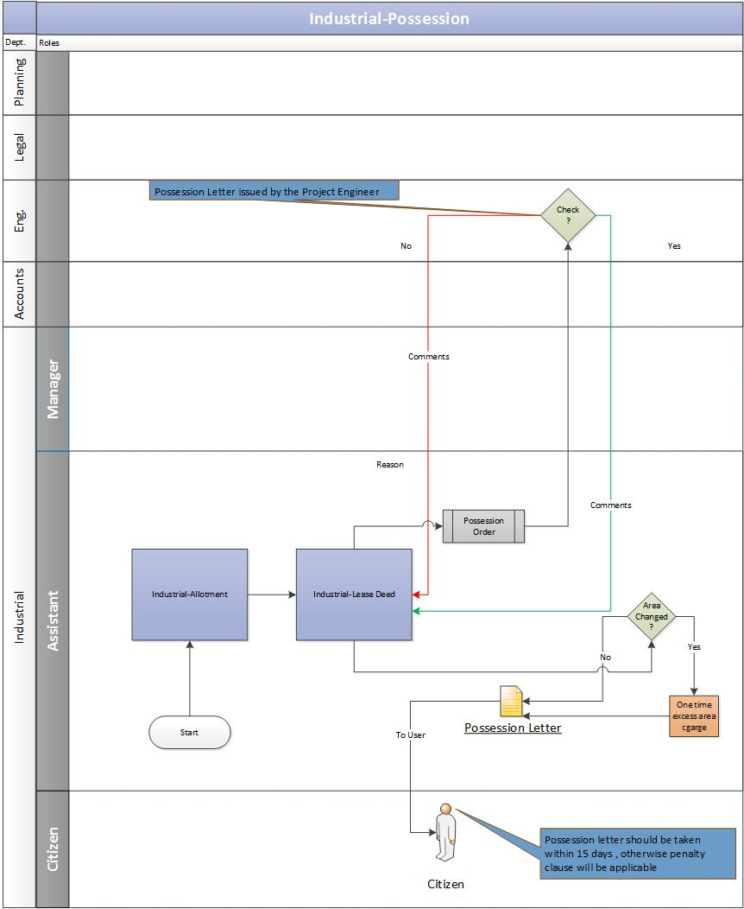

Consumer submits application
    - The Customer duly submits the application along with the required documents to get the possession certificate for the property.

Approval from engineering department
    - Assistant would validate the documents of the allotted property and send the possession order to the project engineer for further action:
      - If the project engineer does not approve the possession order, then he/she is required to send the valid reason to the assistant.
      - If the project engineer approves the possession order, the assistant will issue the possession letter to the Customer.

Re-Adjustment of Change in Area
    - If there is a change in the property area during the possession phase, the assistant would readjust the area amount and would notify the same to the Customer.
      - In case of increase in area, the assistant would calculate the excess amount and ask the Customer to pay the same as a one-time payment. Once the Customer pays the one-time excess amount, he will be issued the possession certificate.
      - In case of decrease in area, the assistant would the re-adjust the amount and reschedule the installments of the Customer.

Business Rules for Possession
- If there is a change in the property area during the possession phase, the assistant would readjust the area amount and would send the same to the Customer.
- In case of increase in area, the assistant would calculate the excess amount and ask the Customer to pay the same as a one-time payment. Once the Customer pays the one-time excess amount, he will be issued the possession certificate.
- In case of decrease in area, the assistant would the re-adjust the amount and reschedule the installments of the Customer.
- The possession letter should be requested by the Customer within a stipulated time-frame (currently 15 days) from the time the possession order was approved. If he misses this time-frame, he would have to pay the penalty as decided by the authority.
- As per the recent regulation passed in year 2014, possession certificate can be applied if the transferor has paid all his/her dues and once the Possession certificate is issued, the remaining number of payments will be paid by the transferee.

Request of Completion Certificate

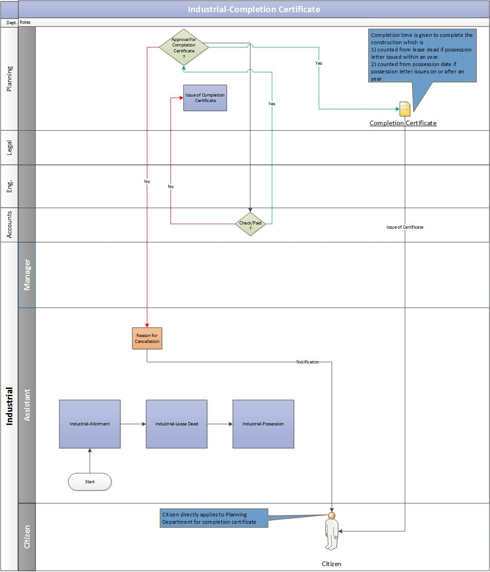

Consumer submit Completion Certificate Request
    - The allottee duly submits the completion certificate request along with the required documents to the concerned department at Noida Authority.

Validation from Planning & Account Department
    - The Planning department receives the completion certificate request and would validate the allottee’s documents.
    - The planning department verifies with the accounts department whether the Customer has paid for the completion charges:
      - If the completion charges are paid by the Customer and the account department gives a go-ahead then the Planning department would issue the completion certificate to the Customer.
      - If the completion charges are not paid by the Customer then the Planning department would not issue the completion certificate to the Customer.

Business Rules for Completion Certificate
- It is mandatory to get the completion certificate issued after lease deed is executed for property within a stipulated time-frame (Currently 2 years).
- If the completion certificate is not issued then extension charges will applied up to date.
- It is mandatory to have the completion certificate before the transfer of property.

Request for Functional Letter

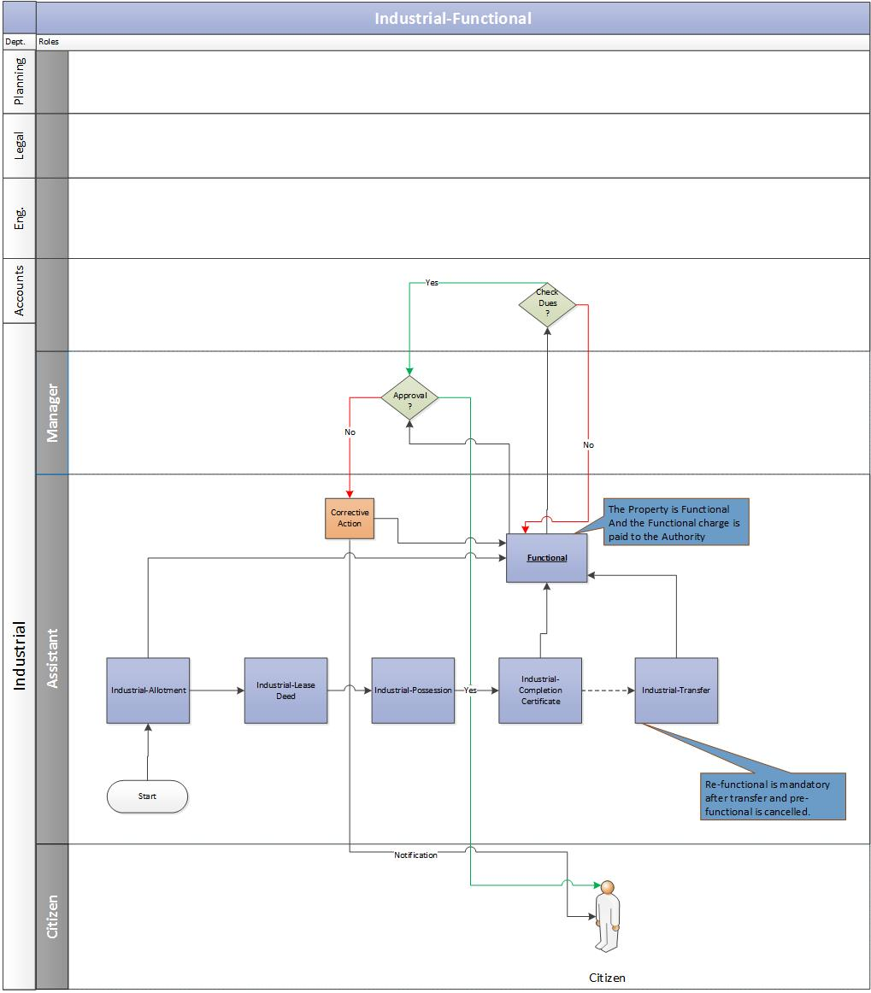

Consumer Submits Functional Request
    - The allottee duly submits the Functional letter request along with the required documents to the concerned department at Noida Authority.

Validation from Account Department
    - The assistant receives the functional request and would send the same to account department to validate the allottee’s account details for any pending dues.
    - The account department would verify the allottee’s account details. In case of no pending dues, the account department would issue a No Dues certificate.

Approval from Manager
    - After receiving the confirmation from accounts department, the assistant would send the Functional request to the manager for his approval.

Functional Letter Issuance
    - Once the manager approves the functional request, the assistant would issue the Functional letter to the Customer.
    - In case any previous dues exists, the assistant would notify the Customer to clear the previous dues first before applying for the functional letter.

Business Rule for Functional
SL. No. | Area of plot (in sqr. mtr.) | Minimum percentage of total FAR to be constructed
1. | Upto 4000 | 50
2. | 4001-10000 | 40
3. | 10001-20000 | 35
4. | 20001-100000 | 30
5. | 100001-200000 | 25
6. | 200001-400000 | 20
7. | Above 400000 | 15
- An industrial unit, on submission of the following documents, may be declared functional:
  - Certified copy of PMT SSI Registration/Central Excise Department Certificate indicating date of production/Trade Tax Exemption order/Trade Tax Assessment Order/ STPI registration certificate along with documentary evidence of functioning.

Note: The minimum percentage are area of plot may vary in the future

  - Affidavit showing that below mentioned percentage of the maximum permissible covered area been constructed / building completion certificate has been obtained and the unit is functional at site. In case affidavit is found wrong or factually incorrect then NOIDA will take administrative action for cancellation of the plot or any other action as deemed fit.
  - Lease Deed/Transfer Deed/Sale Deed as applicable has been executed and registered and its certified copy duly submitted in NOIDA office.
  - No dues certificate of Accounts Officer (IAA), NOIDA
  - In addition to the above stated documents the following documents as applicable may also be required to be submitted by the allottee(s)/lessee(s)/transferee(s) claiming date of functioning with retrospective effect:
- ESI registration certificate/returns
- PF registration certificate/returns
- Registration under Factories Act
- Electricity consumption bills
- Bank statement
- Any other document in support of their claim
  - The date of commencement of production indicated in PMT SSI Registration Certificate/Certificate issued by Central Excise Department/Trade Tax Assessment Order would be deemed as date of production and extension charges, if applicable, would be payable only till this date irrespective of the date of submission of the documents and/or declaration of unit as functional by NOIDA.
  - The Industrial facility units on submission of the following would be declared functional:-
    - Affidavit showing the construction of minimum percentage of maximum permissible covered area as per table given above has been constructed / building completion certificate has been obtained. In case affidavit is found wrong or factually incorrect then NOIDA will take action as deemed fit.
    - Transfer Deed as applicable has been executed and registered and its certified copy duly submitted in NOIDA Office.
    - No Dues Certificate from A.O. (IAA), NOIDA.
    - Telephone Bills.
    - Meter Ceiling Certificate and Electric Consumption Bills.
    - Purchase bills of Machinery.

Request for Transfer of Property

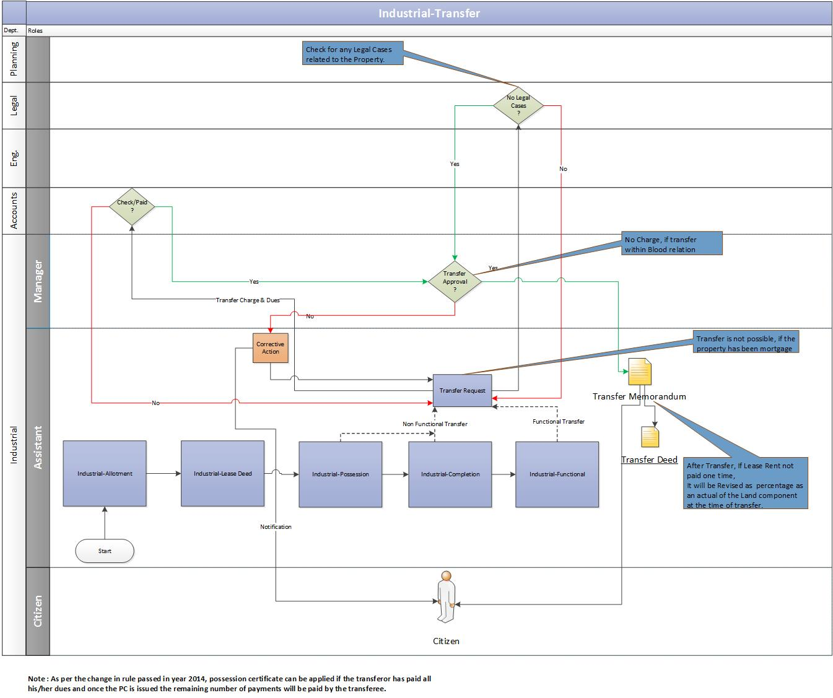

Consumer submits Application
    - The transferor (allottee) of the property submits the transfer application request to the respective department at the Noida Authority.

Validation from Accounts & Legal Department
    - Assistant would receive the transfer request and validate the allottee’s account details and litigation details to the concerned departments.
    - The account department would verify the allottee’s account details. In case of no pending dues, the account department would issue a No Dues certificate.
      - The legal department would verify if there are any legal cases on the property. In case of no legal cases, the legal department would issue a clearance certificate.
      - Post verification from the accounts and legal departments, the assistant would ask the Customer to pay the transfer charges.

Consumer pays transfer charges
    - The Customer pays the transfer charges and updates the same to the authority.
    - The assistant verifies the transfer payment details with the account department.
    - After receiving the payment confirmation from accounts, the assistant would send the transfer request to the manager for his approval.

Approval from Manager
    - Once the manager approves the transfer request, the assistant would issue the Transfer memorandum to the Customer.

Transfer Deed Executed
    - Based on the transfer memorandum, the transfer deed will be executed.

Business Rule for Transfer of Property
- When an allottee/lessee i.e. Individual Person (Proprietorship Firm) / Partnership firm/Pvt. Ltd. Co./Ltd. Co. wants to sell/transfer a unit located on an allotted plot to any another Individual Person (Proprietorship Firm) / Partnership firm/Pvt. Ltd. Co./Ltd. Co., it may be permitted as below:-
    - Transfer of functional & non-functional units shall be permitted.
    - The cases where cancellation has been effected are not eligible for transfer.
    - Only bonafide lessee(s)/transferee(s) may be permitted to transfer an industrial unit/plot/shed allotted to him, abinitio and/or under expansion category.
    - More than one Industrial Property(s) allotted as one allotment can also be transferred individually to different transferee (s).
- The Transfer Application Form should be duly filled in along with the NOC’s from various departments i.e. Project Engineer (Jal), Accounts Officer (Industrial Area Accounts), UPPCL/last paid electricity bill and General Manager, DIC, NOIDA. (In case all original as well as subsequent legal documents are submitted, then NOC from UP Financial Corporation/Bank/Financial Institution is not required.)
- Both transferor and transferee must be competent to contract on the date of transfer application.
- Transfer charges are 8% (may vary in future) of the current allotment premium of the plot for functional units. Functional unit means the unit already declared functional by NOIDA through a written communication.
- In case of non-functional unit, transfer charges are 10% (may vary in future) of the current allotment premium of the plot & time extension charges upto the date of submission of transfer application are not payable. In case of transfer of property allotted on sealed tender/auction basis, transfer charges would be leviable on the allotted price/current reserve price whichever is higher.
- Transferor and transferee should severally and/or jointly satisfy themselves about the over dues/dues position from the Accounts Department (Industrial) of the Authority.
- Once transfer is approved and Transfer Memorandum is issued and transfer deed is executed, all the assets and or liabilities against the industrial unit would pass on to the transferee.
- Lease rent will be charged @2.5% (may vary in future) of the prevailing allotment premium with location charges, on the date of issue of transfer memorandum subject to enhancement as envisaged in Lease Deed/Transfer Deed /Transfer Memorandum.
- In case of transfer of rights, even partial, of a minor, orders of the judiciary are required regarding the protection of interest of the Minor.
- Transfer of industrial properties by allottee/transferee directly or through registered GPA, to parents, grandfather, grandmother, grandchildren, children, wife, & vice-versa would be allowed without charges, subject to payment of transfer processing fee (amount will be decided as per the rule).
- Once the transfer application is submitted it can be withdrawn only with the consent of the transferor and the transferee.
- The lessee/transferee shall execute a Transfer deed, after paying the necessary transfer charges, within 90 days from the date of issue of the Transfer Memorandum and a certified copy of the same shall be submitted to the NOIDA after the registration of the same with the sub Registrar, NOIDA. The Transfer Memorandum shall be the part of the transfer deed executed between the Transferor and the Transferee. In case of default, appropriate penalty would be levied. Currently, the penalty shall be levied @ Rs. 50 per day on plots measuring upto 200 sq.mtrs., @ 100 per day on plots measuring upto 800 sq.mtrs. and @ Rs. 200 per day on plots area above 800 sq.mtrs.
- In case of mutual transfer between transferor and transferee, the transferee would make the unit functional within one year from the date of issue of Transfer Memorandum. However, the facility of extension for making the unit functional would be available to the transferee on payment of prescribed extension charges after expiry of one year.
- Transfer through a registered General Power of Attorney (GPA)
- Transfer within the blood relations of the registered General Power of Attorney (GPA) holder would be allowed on a stipulated payment amount (currently, its 1.5 times of the normal transfer charges). Other than blood relatives of the registered GPA holder, the transfer charges shall be 2 times of the normal transfer charges.

Request for Issue of Mutation (Substitution)

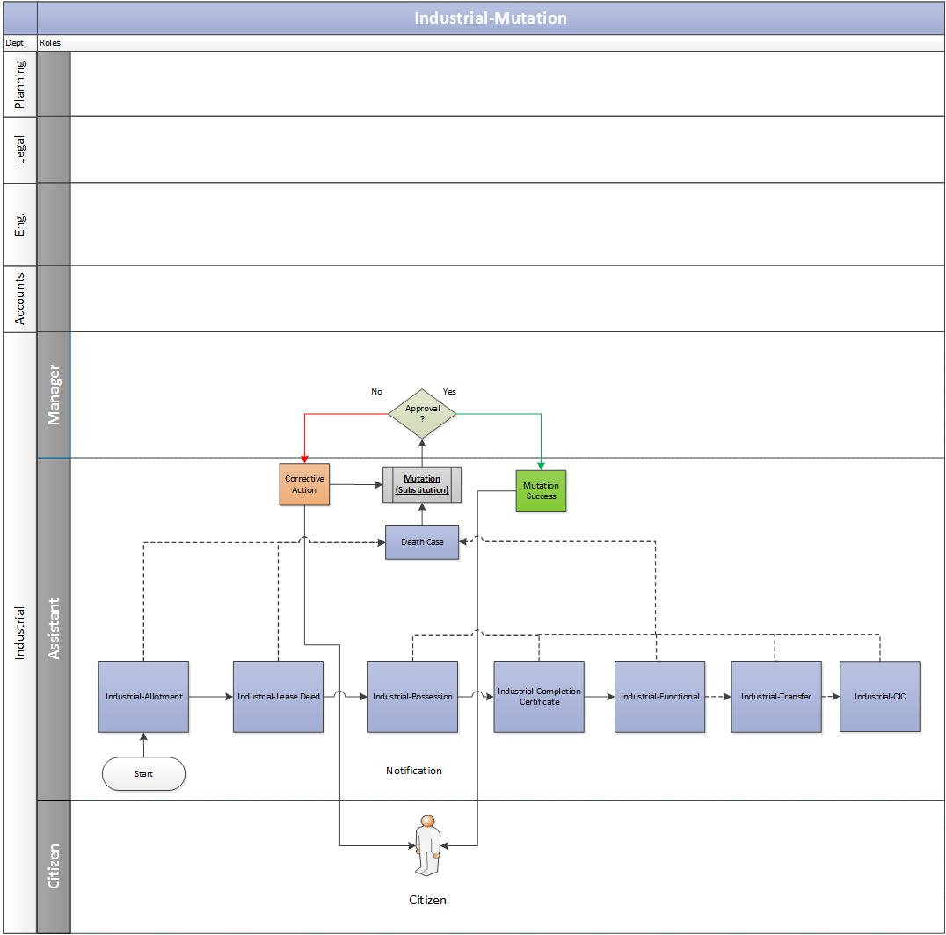

Consumer submits Application
    - If the owner of the property dies then the transferee/beneficiary of the property submit the application along with required documents at the housing department of the authority.

Validation of Documents
    - The assistant receives the mutation (substitution) request and validate the application and documents attached to it.

Approval from manager
    - If the papers are in place, the assistant would send the mutation request to the manager for his approval:
      - If the manager approves the mutation request, the assistant would issue the mutation letter to the Customer.
      - If the manager rejects the request, a notification would be sent to the assistant. The assistant would then share the same with the Customer.

Business Rules for Mutation
- Mutation after transfer of property is valid and possible.
- Mutation after transfer is always chargeable however in case of death it is not chargeable.

Request for Mortgage

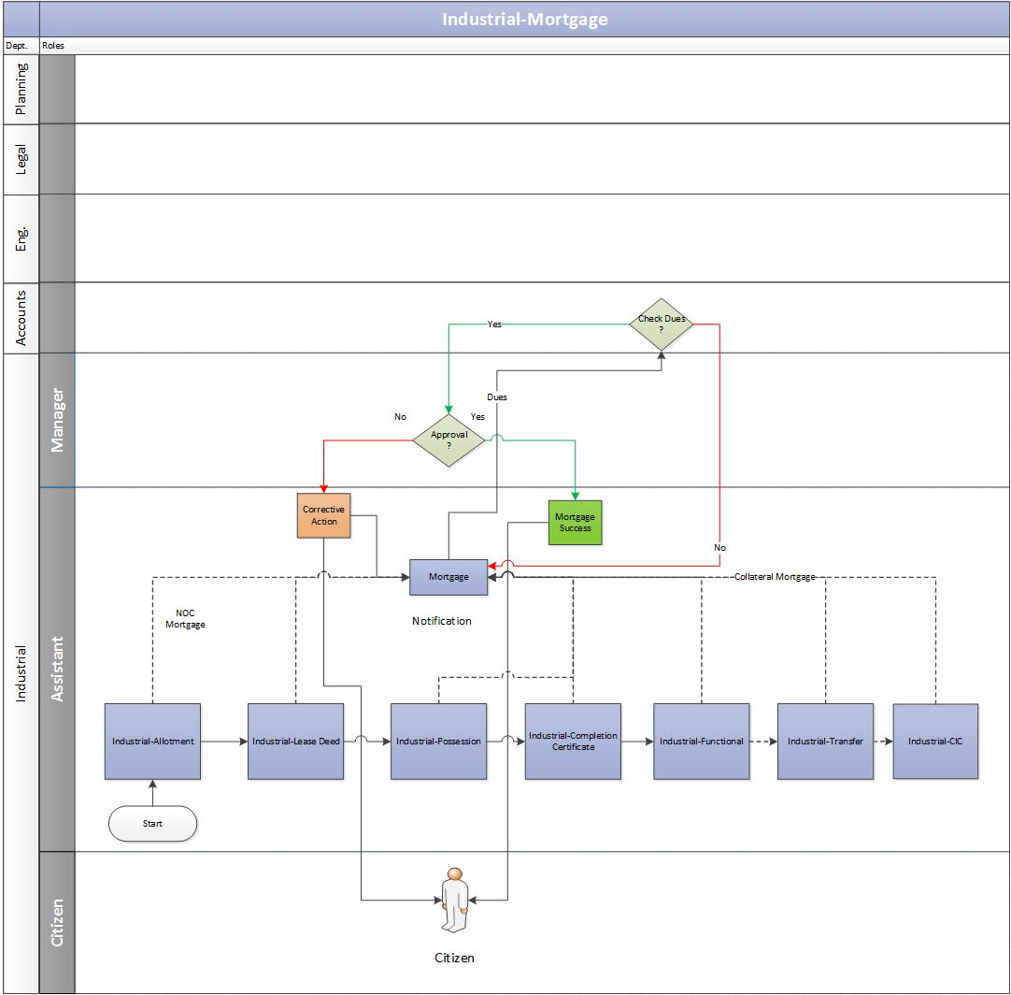

Consumer submits mortgage request
    - The allottee duly submits the mortgage request along with the required documents, for the construction or re-construction on the plot allotted, to the concerned department at Noida Authority.

Validation from Account department
    - The assistant receives the mortgage request and would send the same to account department to validate the allottee’s account details for any pending dues.
      - The account department would verify the allottee’s account details. In case of no pending dues, the account department would issue a No Dues certificate.

Approval from Manager
    - After receiving the confirmation from accounts, the assistant would send the mortgage request to the manager for his approval.

Mortgage Letter Issuance
    - Once the manager approves the mortgage request, the assistant would issue the Mortgage letter to the Customer.
    - In case any previous mortgage exists, the assistant would notify the Customer to clear the previous dues first before applying for fresh mortgage.

Business Rules for Mortgage
- Mortgage is permitted where property is live and time limit for construction exists. No prior mortgage permission is required in cases where full premium alongwith interest and one time lease rent has been paid.
- Permission for collateral security would only be granted in cases where the unit has already been declared functional by the Authority. For the purpose of granting collateral security, processing fee would be charged as per the rule.
- Mortgage is permitted for financing the project on the industrial premises proposed for mortgage.

Request for Change in Constitution (CIC/CIS/CIN/COD)

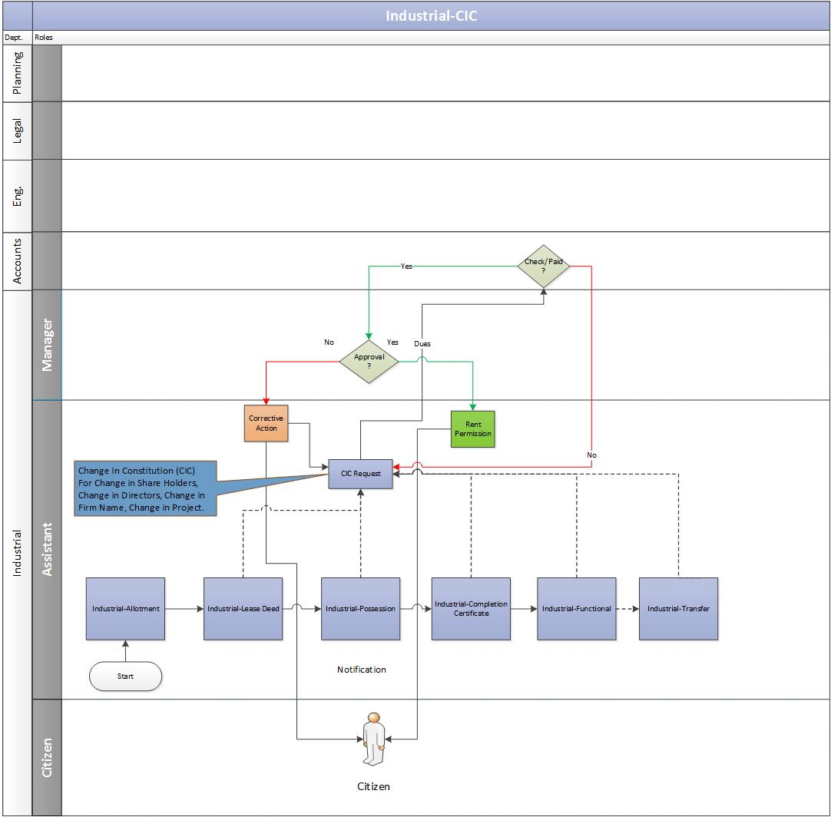

Consumer submits Application
    - The allottee duly submits the application along with CIC charges with required documents to the authority.

Validation from Account department
    - The assistant receives the CIC request and would send the same to account department to validate the allottee’s account details for any pending dues.
      - The account department would verify the allottee’s account details. In case of no pending dues, the account department would issue a No Dues certificate.
      - In case any previous dues exists, the assistant would notify the Customer to clear the previous dues first before applying for the CIC letter.
    - Post verification from the accounts departments and if no dues exists, the assistant would ask the Customer to pay the CIC charges.
    - The Customer pays the CIC charges and updates the same to the authority.
    - The assistant verifies the CIC payment details with the accounts department.

Approval from manager
    - After receiving the payment confirmation from accounts, the assistant would send the CIC request to the manager for his approval.

CIC Letter Issuance
    - Once the manager approves the CIC request, the assistant would issue the CIC letter to the Customer.

Business Rules
- Change in Constitution (CIC)
- When an individual person (Proprietorship Firm)/ Partnership Firm/Private Ltd. Co./Public Ltd. Co., having a plot/unit located on an already allotted plot, wants to change its constitution in any of the following manner:-
  - Individual Person (Proprietorship Firm) to Partnership Firm
  - Partnership Firm to Individual Person (Proprietorship Firm)
  - Person (Proprietorship Firm)/Partnership Firm to Private Ltd. Co./Public Ltd. Co.
  - Private Ltd. Co./ Public Ltd. Co. to Partnership Firm/Individual Person (Proprietorship-Firm).
Private Ltd. Co. to Public Ltd. Co. or vice- versa

- For Change In Constitution from Individual Person (Proprietorship Firm) to partnership
- Certified copy of the Partnership Deed.
- Form B regarding registration of firm or any other document to this effect issued by the Registrar.
- Form ‘A’ showing statement regarding name of Partners, or any other document to this effect issued by the Registrar of firms of respective State.
- Notarized affidavit stating the relationship of the incoming partners with the allottee/transferee. (In case exemption from payment of CIS charges is sought).

- For Change In Constitution from partnership to Individual Person (Proprietorship Firm)
- Certified copy of the Dissolution Deed.
- Notarized affidavit stating the relationship of the incoming partners with the allottee/transferee. (In case exemption from payment of CIS charges is sought).

- For Change In Constitution from Individual Person (Proprietorship Firm) /Partnership Firm to Private Ltd. Co./ Public Ltd. Co.
  - Certified copy of the Memorandum and the Article of Association.
  - Certified copy of Certificate of Incorporation issued by the Registrar of Companies of the respective State.
  - Certified list of Board of Directors and certified list of shareholders showing number of shares and their value along with their addresses.
  - Duly certified Resolution of Board of Directors regarding taking over the industrial property by the Company from the Individual Person (Proprietorship Firm)/the Partners. Also the resolution in favour of the person authorized by the Board of Directors of the Company to correspond with the NOIDA.
  - Notarized affidavit duly sworn and attested regarding the relationship of the shareholders with the allottee(s). (In case exemption from payment of CIS charges is sought.)
  - In case of a Public Ltd. Co. certified copy of the Certificate of Commencement of Business issued by the Registrar of Companies of the respective State is also to be submitted.

- For Change In Constitution from Private Ltd. Co. / Public Ltd. Co. to Partnership Firm/ Individual Person (Proprietorship Firm)
  - Certified copy of the Partnership Deed.
  - Notarized affidavit stating the relationship of the incoming partners with the allottee/transferee. (In case exemption from payment of CIS charges is sought).
  - Duly certified Resolution of Board of Directors regarding change from pvt. Ltd. to partnership firm/Individual Person (Proprietorship Firm) handing over the industrial property by the Company to the Individual Person (Proprietorship Firm)/the Partners. Also the resolution in favour of the person authorized by the Board of Directors of the Company to handover the possession.

- For Change In Constitution from Private Ltd. Co. to Public Ltd. Co. or vice- versa
  - Certified copies of the Memorandum and the Articles of Association of both the Companies
  - Certified copies of Certificate of Incorporation of both the Companies issued by the Registrar of Companies of the respective State.
  - Certified lists of Board of Directors and certified list of shareholders of both the Companies showing number of shares and their value along with their addresses.
  - Duly certified Resolutions of the Board of Directors of both the Companies regarding handing over/ taking over the industrial property by the Company and regarding the person authorized by the respective Board of Directors of the Company to correspond with the NOIDA.
  - Notarized affidavit duly sworn and attested regarding the relationship of the shareholders with the allottee(s)/lessee(s)/transferee(s). (Only in case exemption from payment of CIS charges is sought.)
  - In case of a Public Ltd. Co. certified copy of the Certificate of Commencement of Business issued by the Registrar of Companies of the respective State is also to be submitted.
  - Any other documents required by the Registrar of Companies of the respective State.

- There will be no charges for Change in Constitution. However if in any firm/company change in shareholdings is outside the blood relations, CIS charges will be leviable in proportion to the shares being transferred. However, no CIS charges will be leviable in case the change in shareholdings is amongst father, mother, grandparents, sister, brother, son, daughter, husband/wife, grandson/granddaughter, wife of son/son-in-law, husband of granddaughter, wife of grandson of the allottee(s)/transferee(s).

- The lease rent payable would not be revised as a consequence of Change in Constitution.

- After Change in Constitution, a Change in Constitution Deed would be executed between the former and later Firm/Company. In case the property is acquired by way of transfer, and/or Firm/Company is changed by way of Change in Constitution, they would be required to execute the Transfer Deed. In exceptional circumstances, the authority may consider execution of fresh lease deed in favour of the new Firm/Company after execution and registration of the surrender deed by the old allottee(s)/ lessee(s)/transferee(s).

- Change in ShareHolding (CIS)
- Change in shareholding means change of shares (upto 100%) from any existing shareholder(s) to any other shareholder(s)/ person(s), within the same Firm/Company.

- The cases where cancellation has not been affected are eligible for change of shareholding. The application for change of shareholding should come from lessee/transferee along with following documents:
  - Processing fee. Currently, it is Rs.5 000/- (amount may vary in future) in the shape of a Bank Draft payable at NOIDA/Delhi/New Delhi.
  - List of Directors/Shareholders along with shareholding duly certified by the Chartered Accountant (in case of Pvt. Ltd. /Ltd. Company).
  - Details of changes in percentages of shareholding after induction of new partner(s), duly certified by Registrar of Firms along with certified copy of the new partnership deed (in case of a Partnership Firm).
  - Notarized affidavit stating the relationship of the incoming partners/shareholders with the allottee(s)/transferee(s). (Only in case exemption from payment of CIS charges is sought).

- Charges for Change in Shareholding only in case of partnership firm will be 8% (may vary in future) in functional units and 10% (may vary in future) in non-functional units on 100% change in shareholding and for less than 100% change, CIS charges would be proportionate to the change of shares/holding on a pro-rata basis.

- The lessee / transferee will be required to execute change of shareholding deed with the Sub-registrar for the percentage of change in shareholding only in case of partnership firm.

- Change of partners of a firm along with shareholding on registered GPA basis (only in cases where the unit has been declared functional by the authority through a written communication):

- Change in partners of a firm, along with changes (upto 100%) in their respective shareholdings, may be allowed on the application of the lessee/transferee on the basis of the copies of the documents issued by the Registrar of Firms of the respective State and duly certified by the Chartered Accountant, including the cases where the changes in shareholdings were carried out with the office of the Registrar of Firms and/or the registration of the GPA and execution of the Agreement to Sell were carried out.

- No CIS charges would be leviable in case the change in shareholding is limited to only blood relations.

- In case where the change in shareholding is not between the blood relations, but the registered GPA holder and proposed transferee are blood relations, the CIS charges will be 1.5 times of the normal CIS charges.

- In case where the registered GPA holder and the proposed transferee are not blood relations the CIS charges would be 2 times of the normal CIS charges. Thereafter the CIS charges will be increased @ 50% of the normal CIS charges for every subsequent Agreement to sell / registered GPA.

- For changes within a Partnership Firm:
The following documents shall be required to be submitted to the NOIDA for seeking permission for any changes in the partners / shareholdings within a Partnership Firm:
- Dissolution deed, New Partnership deed, Retirement-cum-Partnership deed of the Partnership Firm issued by the Registrar of Firms of the respective State.
- Form ‘C’ & Form ‘A’ issued by the Registrar of Firm or any other document to this effect issued by the Registrar of Firms of the respective State.
- Notarized affidavit stating the relationship of the incoming partners with the allottee(s) / transferee(s). (Only in case exemption from payment of CIC charges is sought.)
- For changes within a Private Ltd. Company/Public Ltd. Company, the following documents shall be required to be submitted to the NOIDA for seeking permission for any changes in shareholder(s) / shareholdings of a Company:
  - Certified list of the shareholder with their respective shareholding, duly certified by the Chartered Accountant.
  - List of Directors duly certified by the Chartered Accountant, along with Form 32 duly receipted by the Registrar Of Companies (R.O.C) of the respective State.
  - Board Resolution duly certified by the Chairman of the Board Meeting/Chartered Accountant.

- Charges for change in shareholding will be in proportion of shares transferred only in case of partnership firm. However, no charges will be leviable in case incoming partner are father, mother, grandparents, sister, brother, son, daughter, husband/wife, grandson/granddaughter, daughter in law /son-in-law, husband of granddaughter, wife of grandson of the allottee(s)/transferee(s).

- No CIS charges will be applicable for transfer of shareholding (upto 100%) from husband to wife, parent to children, grandfather, grandmother, grandchildren and/or vice versa. However, processing fee of Rs. Rs.5,000/- (amount may vary in future) will be payable along with the application for the same.

- The lease rent payable would not be revised as a consequence of Change in Constitution.

- Change in Name (CIN)
- If the name of a firm/company changes with the original firm/company not remaining in existence and partners/shareholders of the firm/company remaining the same and shareholding of the respective partners/shareholders also remaining the same, no CIN charges will be leviable and only a declaratory agreement without registration would be executed and submitted to the NOIDA.

- If the name of a firm changes with original firm remaining in existence and partners of the firm also change, then CIS charges would be leviable and the allottee(s)/lessee(s)/transferee(s) would also have to execute the required legal documents with the Office of the Sub-Registrar, Noida.

- Change in Directors (CID)
- In case only the director(s) of a Private Ltd. co./Public Ltd. Co. Change, without any change in the shareholdings, the concerned company would be required to inform the Noida accordingly.

Request for Rent Permission

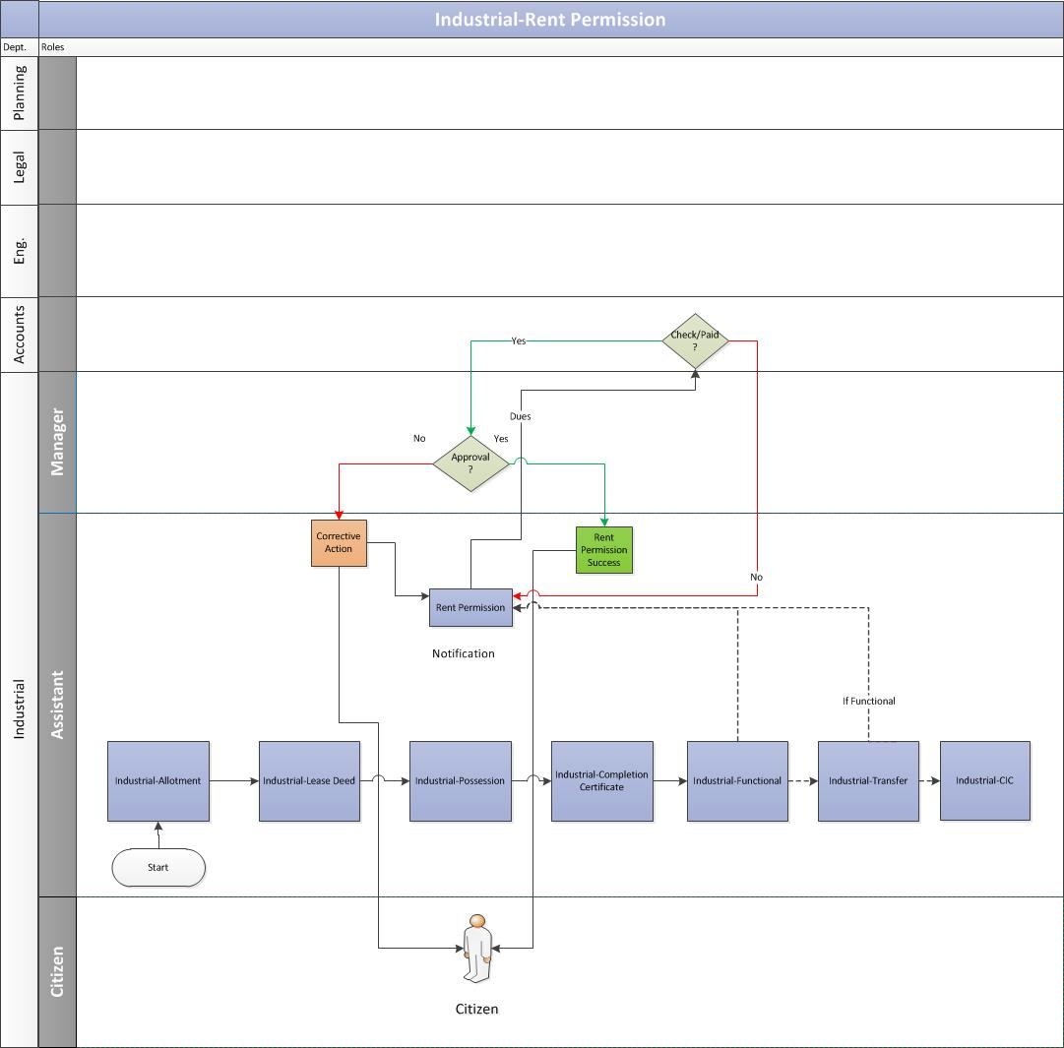

Consumer submits application
    - The allottee duly submits the application along with the rent permission charges with required documents to the authority.

Validation from Account department
    - The assistant receives the rent permission request and would send the same to account department to validate the allottee’s account details for any pending dues.
      - The account department would verify the allottee’s account details. In case of no pending dues, the account department would issue a No Dues certificate.
      - In case any previous dues exists, the assistant would notify the Customer to clear the previous dues first before applying for the rent permission letter.
    - Post verification from the accounts departments and if no dues exists, the assistant would ask the Customer to pay the rent permission charges.
    - The Customer pays the rent permission charges and updates the same to the authority.
    - The assistant verifies the rent payment details with the accounts department.

Approval from manager
    - After receiving the payment confirmation from accounts, the assistant would send the rent permission request to the manager for his approval.
    - Once the manager approves the request, the assistant would issue the rent permission letter to the Customer.

Business Rules for Renting

- For the purpose of part renting, the applicant has to clearly demarcate the portion of the building to be given on rent. He has also to file an Affidavit specifying the position of capital subsidy or any other subsidy, having been received or not and the premises having been mortgaged or not.

- Renting permission is granted if:

- Upto date dues of authority have been cleared.
- Lease deed/Transfer deed/Sale deed as applicable has been executed and registered and certified copy is duly deposited with the office.
- NOC’s of the term lending Institution (s), in case the industrial premises is mortgaged/ offered as collateral security.
- Bonafide lessee while making the request for renting would append a copy of the Project Report of the proposed project of the tenant. Projects free from pollution & environmental hazards shall be considered.

- In case of discontinuation of tenancy, the same would be taken on record after the lessee surrenders the original renting permission letter.
- In case of re-renting, the renting charges would be deposited again as stated here below.
- The condition of functionality and renting charges may be waived off in case the renting permission is sought for a Group/Associate/Sister/subsidiary concern in which allottee/lessee or their shareholders have jointly and/or severally minimum stipulated shares (currently 51%).
- Industrial allottees of IT units on Institutional terms and conditions and other than approved IT parks, number of tenants would be one for every 500 sq.mt. and charges for tenancy would be @ Rs. 100 per sq.mt. of built up area per year for first tenant and for every subsequent tenant 20% of original charges would be levied.
- For all industrial allottees other than IT units allotted on institutional terms and condition basis, no. of tenants permitted would be one for every 500 sq.mtr. plot area and charges for renting would be as per the above clauses.
- If any tenant leaves tenancy before 10 years then for balance remaining period, permission can be granted for new tenant on payment of 20% of prevailing rate of renting charges for the entire plot area and subject to fulfillment of other terms and conditions.
- In case of built up sheds, the plot area shall be taken into consideration.
- The rent permission can be granted for the period of 5 years also, the renting charges would be 50% of the charges.

Note: The tenure and payment percentage may vary in future.

11. Miscellaneous Business Rules

Surrender

  - The allottee has to execute surrender deed, if lease deed/transfer deed has been executed and all the original legal documents are to be surrendered unconditionally in Industries Department of the Authority.

Restoration of Industrial Plot
The Authority can exercise cancellation of industrial plot/shed for breach of terms and conditions of allotment/lease deed/Transfer deed. However, the Chief Executive Officer/or any other officer authorized by him can restore the plot. The restoration will be subject to the following conditions:-
- The allottee would pay restoration charges @ 10% of the prevailing rate/ reserve price (may vary in future).
- The allottee has to produce NOC of accounts department.
- The allottee has to pay time extension charges as per terms of allotment/lease.
- The allottee will submit project implementation schedule in the shape of affidavit. The maximum time allowed is one year for plot size upto 4000 sq.mtrs. and two years for plot size above 4000 sq.mtrs.
- The allottee has to submit performance guarantee valid for more than three months period of PIS given by him and value of performance guarantee will be 10% of the prevailing price of the plot.
- Transfer and/or Change In Constitution of the unit would not be allowed outside the blood relations, till the unit is declared functional by the authority through a written communication.
- If there is any court case pending before any court, it has to be withdrawn by the allottee. All legal expenses would be borne by the allottee.
- In case allotment has been cancelled due to commercial activities, the restoration of the plot shall only be considered on submission of affidavit for not carrying out the commercial activities in future and on inspection of the site about closing the commercial activities.

Conversion

  - In exceptional circumstances, the request of allottees of industrial plot(s) of 2000 sq. mtrs. can be considered by Chief Executive Officer on the recommendations of the Plot Allotment Committee subject to the following conditions:

    - The allottee is not a defaulter and must have deposited the allotment money along with interest, if any
    - Converted plot is allotted at the land rate prevailing on the date of conversion letter plus conversion charges and location benefit charges as given below.

- Within the allotted industrial Phase - 10% of the land rate prevailing on the date of conversion letter.
- Outside the allotted industrial Phase - 25% of the rate prevailing on the date of conversion letter.

    - The date of issue of conversion letter would be deemed as date of allotment for all practical purposes i.e. for execution of lease deed, possession, interest on balance amount etc.
    - The entire deposits made against the allotted plot would be adjusted.

12. Payment Schedule Logic for Industrial Department

Payment Schedule Formulae
The calculation of the payment schedule for Industries would be done using Equated Monthly Installments. The formula for the same is as follows:

n = Number of installment
r = Rate of interest,
Rate of Interest, r = [N.I./(12/f)]
f = frequency
N.I.= Normal Interest

Calculation of rate of interest as per frequency:
  - In case of Monthly
Frequency, f=12
Rate of Interest, r = N.I./(12/12) [from the rate of interest formula above]
  - In case of Quarterly
Frequency, f=4
Rate of Interest, r = N.I./(12/4) [from the rate of interest formula above]
  - In case of Half Yearly
Frequency, f=2
Rate of Interest, r = N.I./(12/2) [from the rate of interest formula above]

  - In case of Yearly
Frequency, f=1
Rate of Interest, r = N.I./(12/1) [from the rate of interest formula above]

The factor can be calculated as

Factor,F = [POW((1+r/100),n) * r/100]/[POW((1+r/100),n)-1]

So, the installment amount can be calculated as the product of Balance Amount and the Factor (calculated using the above formula), i.e.:

Installment Amount = Balance Amount * Factor

Payment Schedule Example
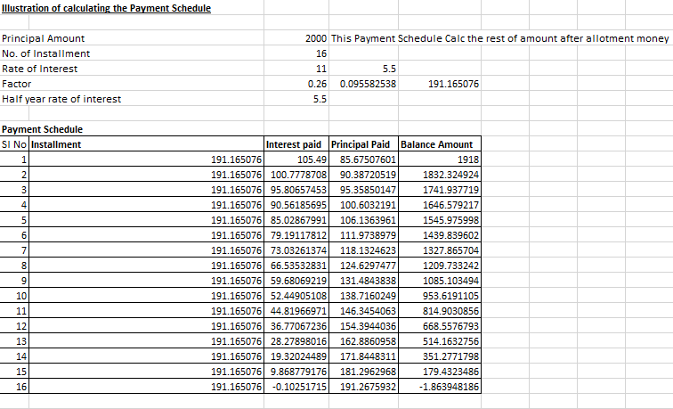
Note:
      - For the industrial properties, payment cycle starts on 30th June or 31st December.
      - The first installment will be applicable after 6 months from receiving allotment letter.
      - The amount of the first installment will be comparatively high from the amount of remaining installments. After allotment, a customer will start the payment of installment after minimum 6 months. In industries, a customer can pay only 2 times in a year and that too half-yearly i.e. on 30th June or 31st December. For example, if the customer receives the allotment letter on 21st February, the first installment will start from 31st December, instead of 30th June because the customer didn’t completed 6 months (requirement after allotment) after allotment till 30th June, so, interest would be calculated from 21st February to 31st December and would be added to the first installment.

Dues Calculation

Example 1 - Part Payment Calculation
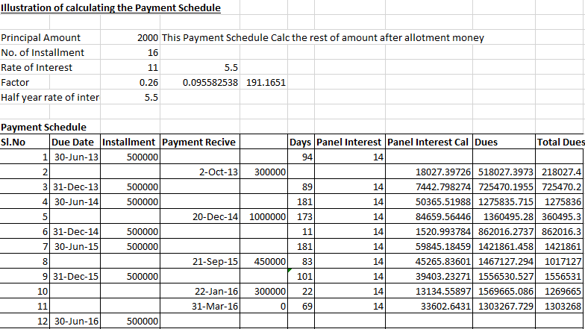

Example 2 – All Payments Outstanding Calculation

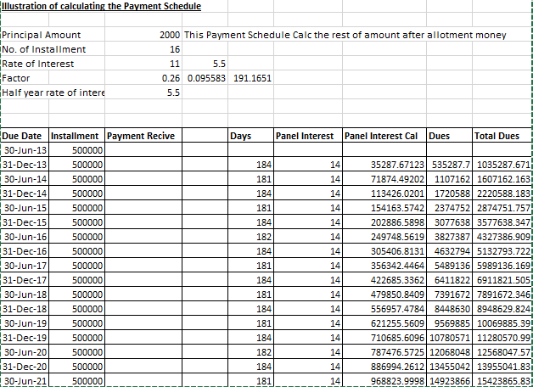

Note:
  - For the first six months (from 1st January to 30th June), the number of days for calculating the daily interest would be 181 days. In the case of leap year, the number of days for calculating the daily interest would be 182 days.

  - For the last six months (from 1st July to 31st December), the number of days for calculating the daily interest would be 183 days.

  - The panel interest will be applicable if the payments are defaulted.

  - If a person defaults, then penal interest would be applied to his outstanding payment. Penal interest can be calculated as

p*(1+r/100)^n

where, P = Principal
r = rate of interest
n = frequency

Miscellaneous
It is mandatory to get the lease deed executed for property after allotment is made within a stipulated time-frame (Currently 30 days).
Post that, penalties will be levied on the citizen based on the below formula:
Penalties = [(One Year Lease Rent)/365) * no of default days +one year lease rent]

Note: After every 10 years lease rent will be revised.

